**SELF ASSESSMENT COMPLIANCE CHECKLIST**

**FOR FACTORY-CONVERTED DORMITORY (FCD) OPERATOR**

This self-assessment compliance checklist serves to assist you in identifying gaps in your dormitory’s compliance with MOM’s requirements for FCDs.

Please note that this checklist is not exhaustive; FCD operators must also comply with the statutory requirements of other government agencies.

|  |  |  |
| --- | --- | --- |
| **Category** |  | **Description** |
| **Approval** |  | **1.** The dormitory has obtained a temporary fire permit or fire safety certificate from SCDF and a Written Permission from URA to operate as a workers’ dormitory. |
| **Overcrowding** |  | **2.** The number of bed spaces and/or number of occupants must not exceed the number specified or approved under the Written Permission issued by URA; and specified or approved under SCDF's FSSD-BP3 form.   **3.** No unauthorised partitioning. Operators should not house workers in areas that differ from the original plans submitted to the various government agencies during the approval stage. |
| **Fire Safety** |  | **4.** There are no highly flammable substances (e.g. LPGs, welding gas cylinders) found near the workers' quarters.  **5.** Adequate power points are provided. All power/electrical points in the workers’ quarters must not be overloaded.  **6.** All exits, escape routes and passageways in the quarters are free of obstruction at all times. |
| **Cooking Area** |  | **7.** There must be a separate designated cooking area for the workers. The cooking area must NOT be located within the workers' rooms, i.e. workers must NOT cook in their rooms. |
| **Lighting and Ventilation** |  | **8.** Adequate lights are installed in each room and corridor, such that workers can easily identify the fire safety routes and fire safety exits, in the event of a fire.  **9.** There is proper ventilation in the workers' rooms. Where necessary, fans or air-conditioning should be installed. |
| **Sanitary and Bathing Facilities** |  | **10.** There are adequate sanitary and bathing facilities for the total number of occupants housed in the dormitory.  *(Note: Sanitary facilities such as 1 water closet, 1 wash basin, 1 bathroom, and 1 portable toilet must be provided for every 15 workers or less.)*  **11.** All sanitary and bathing facilities should be cleaned and in proper working condition.  **12.** Proper and adequate screens must be provided to ensure the sanitary and bathing facilities are hidden from the public's view. |
| **Proper Housekeeping** |  | **13.** The workers' rooms are clean and well-maintained.  **14.** Laundry facilities or services are provided at the quarters.   **15.** There is a designated laundry area away from the workers' rooms, for workers to do their laundry.  *(Note: Drying of clothes within the workers' rooms are strongly discouraged as it often leads to poor ventilation.)* **16.** Proper food and waste disposal area is provided in the quarters. |
| **Pest Infestation** |  | **17.** There are proper rubbish disposal areas that are properly managed. There is no pest infestation (i.e. cockroaches, flies, rodents).   **18.** There is no stagnant water that could cause mosquito breeding. |
| **Personal Lockers** |  | **19.** Each worker shall be provided with a personal locker to store/keep their personal effects. |
| **Assess to**  **Wi-Fi** |  | **20.** Free Wi-Fi is provided for workers in the quarters. |
| **Sick Bay** |  | **21.** Sickbay is provided on-site.  *(Note: If provision of sickbay is not feasible due to site constraints, the main contractor must have a contingency plan to isolate workers with infectious diseases.)* |
| **Feedback Channel** |  | **22.** Both the operator and the workers download the DormWatch app to provide and manage feedback.  *(DormWatch is an app that allows workers to provide feedback on the housing conditions to their dormitory operators, and for the operators to self-rectify. The app tracks the dormitory's responses to these feedback and notifies MOM if an issue has not been resolved after some time.)* |

If you are unable to check any of the boxes above, you must take immediate steps to rectify the issues.

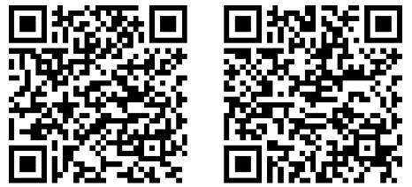**FOR MORE INFORMATION, YOU CAN ASSESS THE FOLLOWING URL:**

Android users iPhone users

DormWatch

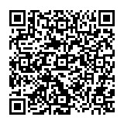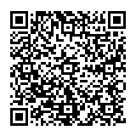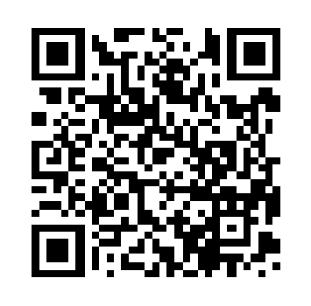

Housing Requirements for FW

https://www.mom.gov.sg/housing

Updating the residential addresses of FW

http://www.mom.gov.sg/eservices/services/

ofwas

Work Pass Conditions

http://www.mom.gov.sg/Documents/services-

forms/passes/WPSPassConditions.pdf

**Annex A**

**Examples of poorly maintained workers’ quarters**

|  |  |
| --- | --- |
| Fire hazard materials and obstruction of exitC:\Users\momtyk1\Desktop\MOM Website Revamp\Photos for Website Revamp\PRP\Bad PRP\IMG_4695.JPG | OvercrowdingC:\Users\momtyk1\Desktop\MOM Website Revamp\Photos for Website Revamp\CTQ\Bad CTQ\IMG_6900.JPG |
| Poorly maintained sanitary facilitiesC:\Users\momtyk1\Desktop\MOM Website Revamp\Photos for Website Revamp\PRP\Bad PRP\IMG_4393.JPG | Pest infestationC:\Users\momtyk1\Desktop\MOM Website Revamp\Photos for Website Revamp\PRP\Bad PRP\IMG_4204.JPG |
| Overloaded electrical power pointC:\Users\momtyk1\Desktop\Overload powerpoint.jpg | Poor housekeepingC:\Users\momtyk1\Desktop\MOM Website Revamp\Photos for Website Revamp\CTQ\Bad CTQ\IMG_6879.JPG |

**Annex B**

**Examples of well-maintained workers’ quarters**

|  |  |
| --- | --- |
| Unobstructed walkway and exit | Ample living space |
| Well-maintained sanitary facilities | Well-maintained dining area |
| Correct use of power pointC:\Users\momtyk1\Desktop\Good Powerpoint photo.jpg | Good housekeeping |