REF: SACT09/2018
Self-Assessment Basic Compliance Checklist for Employment Agencies with Select Licences

The basic compliance checklist assists you to recognize gaps in your employment agency’s compliance to the Employment Agencies Act and its subsidiary legislation, which can be found at http://www.mom.gov.sg/legislation/employment-agencies. It is however not exhaustive, but provides a starting point for employment agencies to perform self-assessment. Please note that relevant forms mentioned can be found at the MOM website at www.mom.gov.sg/forms.

No | Compliance Items | Yes | No
Ensuring Professionalism of EA Industry
1 | EA Name and Licence Number (wef 1 Jun 16)  The EA name and licence number are inserted on:  - any signboards bearing the name of the EA and is visible to public  - any document issued or sent to any other party in the course of the EA’s performance of any function as an EA (including but not limited to invoices, receipts, service agreements, employment contracts and correspondence (whether electronic or otherwise)  - any advertisement publicizing any work or activity for or in connection with the employment of persons (such as but not limited to the EA’s website, name cards, pamphlets and publicity material on any social media platform)  - any advertisement (whether electronic or otherwise) distributed to the public by any other person on the licensee’s behalf
2 | EA Personnel Name and Registration Number (wef 1 Jun 16)  The full names and registration numbers of EA personnel, as stipulated in the EA personnel’s registration cards are inserted in any document or advertisement referred to under item 1 of this checklist.
3 | Personnel Registration  The EA registers all personnel who are performing EA work with MOM.
4 | The EA has at least one Key Appointment Holder who is registered with the Ministry (wef 1 Sep 18)
5 | Registration Cards  The EA’s registered key appointment holders and other EA personnel have Registration Cards which are in line with MOM’s requirements. (Refer to EA Rules 2011 for specifications, or refer to the last page for graphical representation).
6 | Deregistration of EA Personnel  The EA deregisters personnel who have left the EA’s employment or who have stopped performing EA work within 3 working days.
7 | TEP/TWP Holders  The EA does not place Training Work Permit or Training Employment Pass holders.
8 | Update Information to MOM  The EA updates MOM within 7 working days, if there is a change in EA’s place of business.
9 | Any change in any business registration details with ACRA is updated in Licence One.
10 | Retention of Documentations (wef 1 Sep 18)  The EA retain possession of all original documents or copies of such documents (may be retained in an electronic form) for a minimum period of 3 years starting from the date of any work pass application or renewal. (Refer to Annex A – List of Documents to be Retained by the Licensee of EA Licence Condition (EALC))
EA’s Duty of Care to Applicants for Employment
11 | Condition for Placement  The EA only performs job placement for applicants who earn more than SGD$4500 per month (inclusive of fixed allowances, if any).
12 | Prevailing Entry Requirement of Foreign Applicants for Employment  The EA checks all necessary documentation, interviews and screens the Foreign Employee before, and after their entry into Singapore to ensure that they meet the prevailing entry requirements imposed on the Foreign Employee by the Ministry are fulfilled by the Foreign Employee.
13 | Fees  The EA does not charge an applicant for employment more than 1 months’ salary for each year of validity of the applicant’s work pass or period of contract, up to a maximum of 2 months’ salary.
14 | Prescribed Fees  The EA shall not charge or receive any form of fees, remuneration, profit or compensation otherwise than the prescribed fees.
15 | Refund  The EA refunds at least 50% of fees received from an applicant if the employer fails to employ the applicant or if the employer terminates the employment within 6 months.
16 | Itemized Receipt  The EA issues an itemized receipt to the applicant for employment for fees received, whether directly or indirectly, from him/her. The receipt should inform the applicant for employment how much the Singapore EA is charging him/her.
17 | Withholding the Passport of Foreign Applicants for Employment  The EA returns or delivers passports and other documents of identity to foreign applicants directly as soon as practicable.
18 | Retention or Transfer of Passports of Foreign Applicants for Employment  The EA does not make agreements with foreign applicants to retain and/or transfer possession of the foreign employees’ passports or work passes.
EA’s Duty of Care to Employers
19 | Dispute Resolution Mechanism  The EA discloses to clients and applicants for employment the EA’s dispute resolution mechanism prior to engagement of service.
20 | Scale of Fees  The EA clearly communicates in writing the scale of fees to be charged to a client or an applicant for employment. The list of fees should be comprehensive and include all the chargeable services provided by the EA.
21 | If the EA wishes to inform prospective employers of fees, EA must not misrepresent the costs of MOM’s legal or administrative requirements (eg. WP application etc), and must provide a breakdown of such costs to the prospective employer in writing. (wef 1 Jul 14)
22 | After an employer engages the services of an EA, the EA must sign a written agreement with the employer which clearly states the breakdown of fees payable by the employer for MOM’s legal or administrative requirements. (wef 1 Jul 14)
23 | Authorization by clients  The EA obtains written authorization from clients in a form prescribed by MOM prior to making any work pass transaction on behalf of an employer who wants to hire a foreign employee.

For more information, you can visit our MOM website at the following link: http://www.mom.gov.sg/employment-agencies

⁺Please refer to the diagram below depicting MOM’s regulations governing the EA Registration Card:
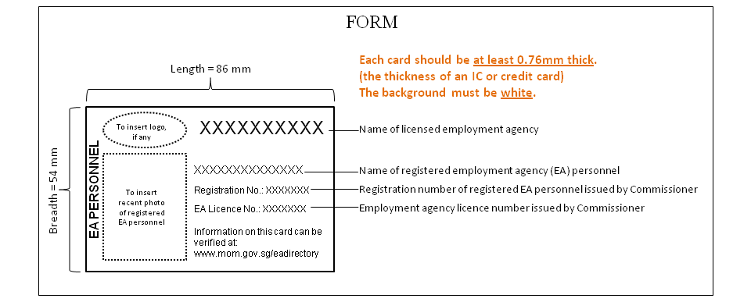
+ Kindly refer to the schedule of Employment Agencies Rules 2011 for full specifications.

