REF: SACT09/2018
Self-Assessment Basic Compliance Checklist for Employment Agencies with Comprehensive Licences (All + Non-FDW)

The basic compliance checklist assists you to recognize gaps in your employment agency’s compliance to the Employment Agencies Act and its subsidiary legislation, which can be found at http://www.mom.gov.sg/legislation/employment-agencies. It is however not exhaustive, but provides a starting point for employment agencies to perform self-assessment. Please note that relevant forms mentioned can be found at the MOM website at www.mom.gov.sg/forms.

No | Compliance Items | Yes | No
Ensuring Professionalism of EA Industry
1 | EA Name and Licence Number (wef 1 Jun 16)  The EA name and licence number are inserted on:  - any signboard bearing the name of the EA and is visible to public  - any document issued or sent to any other party in the course of the EA’s performance of any function as an EA (including but not limited to invoices, receipts, service agreements, employment contracts and correspondence (whether electronic or otherwise)  - any advertisement publicizing any work or activity for or in connection with the employment of persons (such as but not limited to the EA’s website, name cards, pamphlets and publicity material on any social media platform)  - any advertisement (whether electronic or otherwise) distributed to the public by any other person on the licensee’s behalf
2 | EA Personnel Name and Registration Number (wef 1 Jun 16)  The full names and registration numbers of EA personnel, as stipulated in the EA personnel’s registration cards are inserted in any document or advertisement referred to under item 1 of this checklist.
3 | Personnel Registration  The EA registers all personnel who are performing EA work with MOM.
4 | The EA has at least one Key Appointment Holder who is registered with the Ministry (wef 1 Sep 18)
5 | Registration Cards  The EA’s registered key appointment holders and other EA personnel have Registration Cards which are in line with MOM’s requirements. (Refer to EA Rules 2011 for specifications, or refer to the last page for graphical representation).
6 | Deregistration of EA Personnel  The EA deregisters personnel who have left the EA’s employment or who have stopped performing EA work within 3 working days.
7 | TEP/TWP Holders  The EA does not place Training Work Permit or Training Employment Pass holders.
8 | Update Information to MOM  The EA updates MOM within 7 working days, if there is a change in EA’s place of business.
9 | Any change in any business registration details with ACRA is updated in Licence One.
10 | Retention of Documentations (wef 1 Sep 18)  The EA retain possession of all original documents or copies of such documents (may be retained in an electronic form) for a minimum period of 3 years starting from the date of any work pass application or renewal. (Refer to Annex A – List of Documents to be Retained by the Licensee of EA Licence Condition (EALC))
EA’s Duty of Care to Applicants for Employment
11 | Prevailing Entry Requirement of Foreign Applicants for Employment  The EA checks all necessary documentation, interviews and screens the Foreign Employee before, and after their entry into Singapore to ensure that they meet the prevailing entry requirements imposed on the Foreign Employee by the Ministry are fulfilled by the Foreign Employee.
12 | Fees  The EA does not charge an applicant for employment more than 1 month’s salary for each year of validity of the applicant’s work pass or period of contract, up to a maximum of 2 months’ salary.
13 | Prescribed Fees  The EA shall not charge or receive any form of fees, remuneration, profit or compensation otherwise than the prescribed fees (e.g. registration fee, placement fee deposit, etc).
14 | Refund  The EA refunds at least 50% of fees received from an applicant if the employer fails to employ the applicant or if the employer terminates the employment within 6 months.
15 | Itemized Receipt  The EA issues an itemized receipt to the applicant for employment for fees received, whether directly or indirectly, from him/her. The receipt should inform the applicant for employment how much the Singapore EA is charging him/her.
16 | Withholding the Passport of Foreign Applicants for Employment  The EA returns or delivers passports and other documents of identity to foreign applicants directly as soon as practicable.
17 | Retention or Transfer of Passports of Foreign Applicants for Employment  The EA does not make agreements with foreign applicants to retain and/or transfer possession of their passports or work passes.
18 | Furnishing of IPA to Foreign Applicants for Employment (wef 1 Dec 16)  The EA shall take all necessary steps to ensure that the Foreign Employee receives the entire IPA at least 3 to 7 days* prior to their departure for Singapore. EAs shall also allow the Foreign Employees to retain their IPA letter. EAs must be able to furnish documentary proof of such steps.  (Note: To check the details of the IPA sent, i.e. the name and WP no. are the same as our records.) *refer to calendar days
19 | Checks for outstanding claims (wef 1 Jul 14)  The EA makes effort to check that the applicant has no outstanding salary or work injury claims before sending him/her home.
20 | Repatriation of Foreign Applicants for Employment who failed to meet Prevailing Entry Requirement (wef 1 Dec 16)  The EA is to repatriate the FW to an international port of entry within the FW’s home country to allow reasonable access to the FW’s hometown. A different destination is permissible if it is mutually agreed between the FW and the employer, or if the Controller of Work Passes so determines.
EAs which place out FDWs must also adhere to the following regulations:
21 | Prevailing Entry Requirement of FDWs (wef 1 Sep 18)  The standard of verification checks of FDWs shall minimally be in line with the following:  - Examining the FDW’s original official documents (e.g. passport, educational certificate, household listing, national identity card)  - Conducting interview after FDW arrives in Singapore to gather information on the FDW’s family history, education history, work experience, to ascertain if her declared age is consistent  - Assessing FDW’s physical appearance, mannerisms, and speech
22 | FDWs Outside EA Premises (wef 16 Jul 14)  The EA must exercise duty of care to ensure that FDWs are comfortable while within the EA’s premises. FDWs should not be allowed to sit outside the EA’s premises under any circumstances.
23 | Insensitive Advertising by EAs (wef 16 Jul 14)  The EA should refrain from all forms of public advertising (e.g. on shop fronts and websites) that casts FDWs in an undignified light. EA’s advertisements should not make any mention of fees or liken FDWs to merchandise that can be purchased and replaced when found unsatisfactory.
24 | Safety Agreement (wef 1 Dec 12)  Before an FDW starts working, EA must ensure that the prescribed Safety Agreement is explained, agreed, signed and kept by the FDW and her employer. The EA must ensure the FDW retains her Handy Guide as well as any safety guidelines, extendable wiper, etc. provided during SAC/SIP for deployment to the employer. The EA must also furnish the employer with a copy of the safety advisory and FDW observation checklist that is provided by the SIP trainers.
25 | Rest Day Agreement (wef 1 Jan 13)  All FDWs whose Work Permits are applied or renewed on or after 01 Jan 2013 should either be given a weekly rest day or be compensated with extra pay if the FDW agrees to work on her rest day. The EAs must facilitate the signing of the prescribed rest day agreement form between the FDW and her employer.
EA’s Duty of Care to Employers
26 | Dispute Resolution Mechanism  The EA discloses to clients and applicants for employment the EA’s dispute resolution mechanism prior to engagement of service.
27 | Scale of Fees  The EA clearly communicates in writing the scale of fees to be charged to a client or an applicant for employment. The list of fees should be comprehensive and include all the chargeable services provided by the EA.
28 | If the EA wishes to inform prospective employers of fees, EA must not misrepresent the costs of MOM’s legal or administrative requirements (e.g. Costs of SIP, WP application etc), and must provide a breakdown of such costs to the prospective employer in writing. (wef 1 Jul 14)
29 | After an employer engages the services of an EA, the EA must sign a written agreement with the employer which clearly states the breakdown of fees payable by the employer for MOM’s legal or administrative requirements. (wef 1 Jul 14)
30 | Authorization by clients  The EA obtains written authorization from clients in a form prescribed by MOM prior to making any work pass transaction on behalf of an employer who wants to hire a foreign employee.
EAs which place out FDWs must also adhere to the following regulations:
31 | Standard Biodata Format (wef 15 Mar 13)  Prior to any application of a work permit for a FDW, the EA has to furnish the prospective employer the full biodata of the FDW in the form as may be prescribed by the Commissioner.
32 | Employment History (wef 1 Dec 12)  The EA furnishes the FDW’s employment history printed from WPOL system to potential employers. The EA must ensure that the employer signs against the WPOL printout of the FDW’s latest employment history to acknowledge receipt.
33 | Requirements during FDW Transfer  The EA informs the FDW employer of his/her legal responsibilities at the point when he/she returns the FDW to the EA for transfer.
34 | If after 21 calendar days, the FDW has yet to be transferred, the EA must again remind the original FDW employer of his/her legal responsibilities within 7 days.
35 | Service Agreement  The EA’s service agreement for FDW employers must state at least the following:  - Validity period of service agreement  - Fees to be paid by applicant  - GST to be paid  - Amount paid upfront for FDW  - Refund of fees if FDW is not placed  - Refund of fees upon termination and request to transfer FDW  - Refund of fees upon termination, with no approval to transfer FDW  - Refund of fees if replacement FDW is provided  - Refund of fees if employer opts not to have a replacement FDW  - Circumstances under which no refund will be given and terms and conditions to be met in order to qualify for a refund  - Amount payable and timeframe for all refunds  - Provision of replacement FDW if 1st FDW does not commence employment  - Provision of replacement FDW if employer requests to transfer 1st FDW  - Provision of replacement FDW if employer requests to repatriate 1st FDW  - Number of replacement FDWs the employer is eligible for  - Timeframe within which a request for a replacement FDW should be made  - Additional fees charged for replacement FDWs  - Circumstances of non-replacement of FDWs and terms and conditions to qualify for a replacement FDW, if any  - Recourse available if the EA is unable to provide a replacement FDW within the stipulated timeframe  - Fees and terms and conditions for additional services provided by EA  - Dispute resolution mechanism (ensure independent 3rd party is stated, that the 3rd party provides mediation services, and that the EA meets all necessary conditions to be able to use these services.)

For more information, you can visit our MOM website at the following link: http://www.mom.gov.sg/employment-agencies

Please refer to the diagram below depicting regulations governing the EA Registration Card: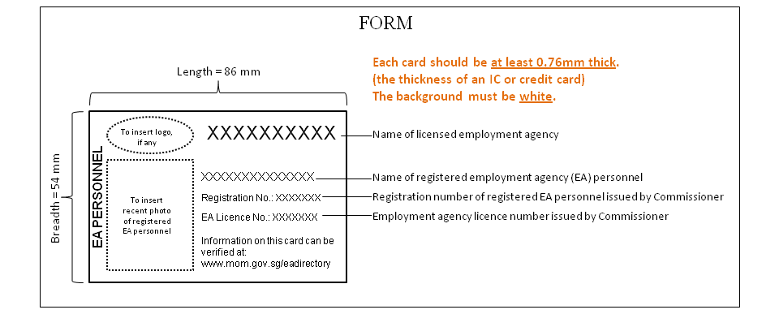
+ Kindly refer to the schedule of Employment Agencies Rules 2011 for full specifications.

