Please note that for new dormitory operators taking over an existing FCD, the operator is required to adhere to the new dormitory requirements.

Factory Converted Dormitory Renewal Application Form
Name/Company Name
Identity/Company Registration No
Contact No & Email
1. Landlord (Lessor/ Building Main tenant or owner)

Name/Company Name
Identity/Company Registration No
Dormitory Address
Contact No & Email
Occupancy Load
2. Existing/Previous operator

3. New operator
Name/Company Name
Identity/Company Registration No
Dormitory Address
Contact No & Email
Name of Dorm Manager
Occupancy Load

4. Dormitory Information
Current Expiry date of URA Temporary Permission

5. Declaration of Facilities (Available to workers)

Facilities (Total) | Number (a) | Total No. of current occupants (b) | Ratio per worker (b/a) Current occupants / Facilities
Shower Points
Urinals
Water Closets (toilet bowls)
Sinks
Electrical Points
Bed Frames
Lockers
Cooking area for workers (Yes/No)

6. Declaration of delineation between dormitory and workspace (Please tick the option)
Residents are able to access their rest areas and all dormitory facilities without the need to enter their workplace(s).
Residents are not able to access their rest areas and dormitory facilities without the need to enter their workplace(s).

Please specify reason(s) and which are the areas in the FCD that the workers need to enter the workplace(s):

Undertaking
I declare that the information provided above is true and correct to the best of my knowledge and beliefs. I understand that it is an offence under Section 22(1)(d) of the Employment of Foreign Manpower Act (EFMA), to provide false information to the Ministry of Manpower. I also understand that offenders will be subjected to a fine of up to $20,000, and/or 24 months’ jail.

Name of Director NRIC / FIN
(last 4 characters only)
Company Name
Date

Please ensure that all submitted photos must be taken no less than 1 week before date of submission
- Picture of Workers Room (Overall View)

- Picture of Workers Room (Overall View)

- Picture of personal lockers

- Picture of washing machines if any (Please submit PDF contract of laundry services if no washing machines on premises.)

- Picture of proper area for workers to dry laundry if not using laundry service.

- Picture of sanitary facilities overall view

- Picture of shower area.

- Picture of water closets (WCs)

- Picture of urinals.

- Picture of proper waste disposal area (Main disposal bin)

- Picture of sickbays that also shows how it is ventilated. (If there is no sickbay at the FCD, please complete part 6 on page 2)
*Please consult with a Qualified Person (QP) or Professional Engineer (PE) if you need approval for
the addition of a sick bay to the dormitory.

- Pictures showing overall cooking area.

- Pictures of cooking area (Zoom in on stoves)

- Pictures of cooking area (Focus on exhaust hood or fans that draw out fumes.)

- Pictures of the cooking area (Focus on storage area for uncooked food)

Rectifications
Subsequent pages to be used only if you are asked to perform rectifications works.

FOR MORE INFORMATION, YOU CAN ACCESS THE FOLLOWING URL:
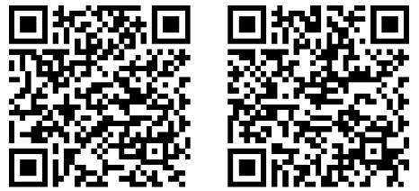
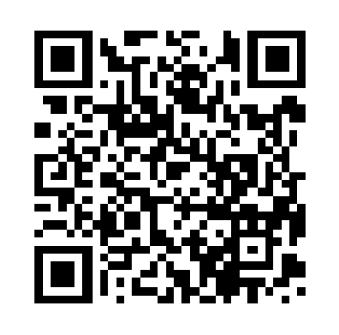
Android users iPhone users
DormWatch
Housing Requirements for FW
https://www.mom.gov.sg/housing
Updating the residential addresses of FW
http://www.mom.gov.sg/eservices/services/
ofwas
Work Pass Conditions
http://www.mom.gov.sg/Documents/services-
forms/passes/WPSPassConditions.pdf

